## Before you collaborate

### A little bit of preparation goes a long way with this session. Here’s what you need to do to get going.

#### 10 minutes

**1**

## Define your problem statement

### What problem are you trying to solve? Frame your problem as a How Might We statement. This will be the focus of your brainstorm.

#### 5 minutes

**2**

## Brainstorm

### Write down any ideas that come to mind that address your problem statement.

#### 10 minutes

**3**

## Group ideas

### Take turns sharing your ideas while clustering similar or related notes as you go. In the last 10 minutes, give each cluster a sentence-like label. If a cluster is bigger than six sticky notes, try and see if you and break it up into smaller sub-groups.

**TIP**

You can select a sticky note and hit the pencil [switch to sketch] icon to start drawing!

#### 20 minutes

**4**

## Prioritize

### Your team should all be on the same page about what's important moving forward. Place your ideas on this grid to determine which ideas are important and which are feasible.

**20 minutes**

## After you collaborate

You can export the mural as an image or pdf to share with members of your company who might find it helpful.

Brainstorm

& idea prioritization

Use this template in your own brainstorming sessions so your team can unleash their imagination and start shaping concepts even if you're not sitting in the same room.

##### Team gathering

Define who should participate in the session and send an invite. Share relevant information or pre-work ahead.

##### Set the goal

Think about the problem you'll be focusing on solving in the brainstorming session.

##### Learn how to use the facilitation tools

Use the Facilitation Superpowers to run a happy and

avoid saying anything that implies the person with disability is superhuman, courageous or specia

**PROBLEM**

Today generation,many specially abled peoples are faces many problems and they have many goals to achieve and not to

communicate to others

smart solution to solve the problem

develop new forms of treatment, accelerate and improve patient care, and better manage electronic

T PRAVEEN RAJA **C JANARDHAAN**

Communication should be universal without any barriers or limitations.

Communication is an important right.

Sometimes people with disabilities have the need for supports due to complex communication needs.

only refer to the person's disability if necessary or relevant

CATEGORY 1 CATEGORY 2

Smart solution to solve the problem

It is very difficult for mute people to convey their message to normal people

Easy to communicate.

# 

use of the automated device

deep learning is used to solve the problem for disabled peoples

pre trained models are used to communicate with disabled peoples

making many revolutionary changes in the life of disabled peoples

making many evalutionary in the life of disabled peoples

cost of this application is less

## Quick add-ons

##### Share the mural

**Share a view link** to the mural with stakeholders to keep them in the loop about the outcomes of the session.

##### Export the mural

Export a copy of the mural as a PNG or PDF to attach to emails, include in slides, or save in your drive.

Improve the knowledge of disabled peoples

**10 minutes** to prepare

website for disabled peoples

Research institutions and medical facilities are using the ability to analyse massive**Ty**d**pe**a**yo**t**u**a**r text** sets to sequence the

human genome

**1 hour** to collaborate

**2-8 people** recommended

productive session.

[**Open article**](https://support.mural.co/en/articles/2113740-facilitation-superpowers)

speak directly to the person rather than the person with them

supported to develop an effective, efficient and reliable means of independent communication

## Key rules of brainstorming

improve the knowledge of disabled peoples

useful to disabled peoples

cost of this application is less

easy to communicate

To run an smooth and productive session

S KIRSHNA

# 

In emergency times conveying their message is very difficult.

Since normal people are not trained on hand sign language.

DINESH

# 

Communication should be universal without any barriers or limitations.

Our objective is to blend deaf and dumb within society and make them able to use their personal computers more effectively and efficiently

## Keep moving forward

##### Strategy blueprint

Define the components of a new idea or strategy.

##### [Open the template](https://app.mural.co/template/e95f612a-f72a-4772-bc48-545aaa04e0c9/984865a6-0a96-4472-a48d-47639307b3ca)

**Customer experience journey map**

Understand customer needs, motivations, and

Stay in topic. Defer judgment.

speak directly to the person rather than the person with them

Encourage wild ideas. Listen to others.

CATEGORY 3

Neural networks can solve somewhat complicated issues at a much easier level concerning the complexity of algorithms

Developing an app will support this vulnerable society of impaired people and enhance communication among people.

devices the new form of treatment and improve patient care better manage electronic health records

use of the automated devices

website for disabled peoples

obstacles for an experience.

##### [Open the template](https://app.mural.co/template/b7114010-3a67-4d63-a51d-6f2cedc9633f/c1b465ab-57af-4624-8faf-ebb312edc0eb)

only refer to the person's disability if necessary or relevant

deep learning is used to solve the problem for disabled peoples

Go for volume. If possible, be visual.

AI technology can apply to any type of disability profile.

It is very difficult for mute people to convey their message to normal people.

##### Strengths, weaknesses, opportunities & threats

Identify strengths, weaknesses, opportunities, and threats (SWOT) to develop a plan.

|  |  |
| --- | --- |
|  |  |
|  |  |

##### [Open the template](https://app.mural.co/template/6a062671-89ee-4b76-9409-2603d8b098be/ca270343-1d54-4952-9d8c-fbc303ffd0f2)

[**Share template feedback**](https://muralco.typeform.com/to/CiqaHVat?typeform-source=app.mural.co)

develop new forms of treatment, accelerate and improve patient care, and better manage electronic health records.

It is very difficult for mute people to convey their message to normal people.

avoid saying anything that implies the person with disability is superhuman, courageous or special

speak directly to the person rather them

only refer to persons disabilities if neccessary or relevant

[**Share template feedback**](https://muralco.typeform.com/to/CiqaHVat?typeform-source=app.mural.co)

## Feasibility

Regardless of their importance, which tasks are more feasible than others? (Cost, time, effort, complexity, etc.)

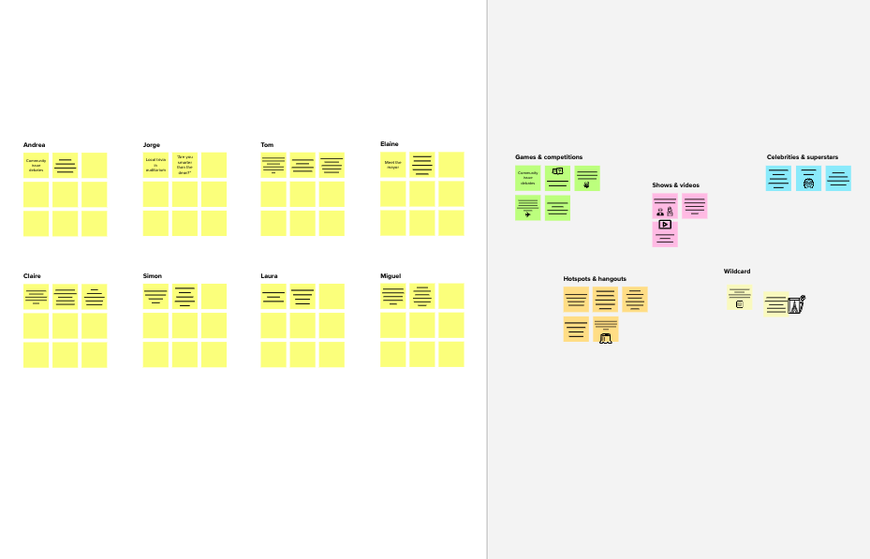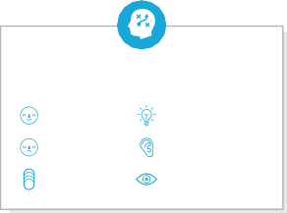

**Template**

**Need some inspiration?**

See a finished version of this template to kickstart your work.

[**Open example**](https://app.mural.co/template/e5a93b7b-49f2-48c9-afd7-a635d860eba6/93f1b98d-b2d2-4695-8e85-7e9c0d2fd9b9)